While still philosophical, I’m much more inclined to espouse abstracted theoretical nonsense than personal implementations. I expect this style of real examples and experiences to be a rare occurrence. Enjoy.

**(0) Scheduling Algorithm : Naive Bogosort**

It’s winter break. The goal of winter break is to hang out with everyone I haven’t seen since going away for college. There’s two or so weeks where everyone is back in town visiting their families and free for the holidays. I want to see as many people as possible to catch up, gossip about others, insult each other, etc.

In scheduling hanging out ultimately the age old question arises: What day are you free? My first iteration was a completely random algorithm because I had no preference on the day to hang out. While I wouldn’t *actually* throw a dart at the calendar until it landed on a day I was free, that was essentially the algorithm I was using to plan my schedule.

My calendar might then look something like this :

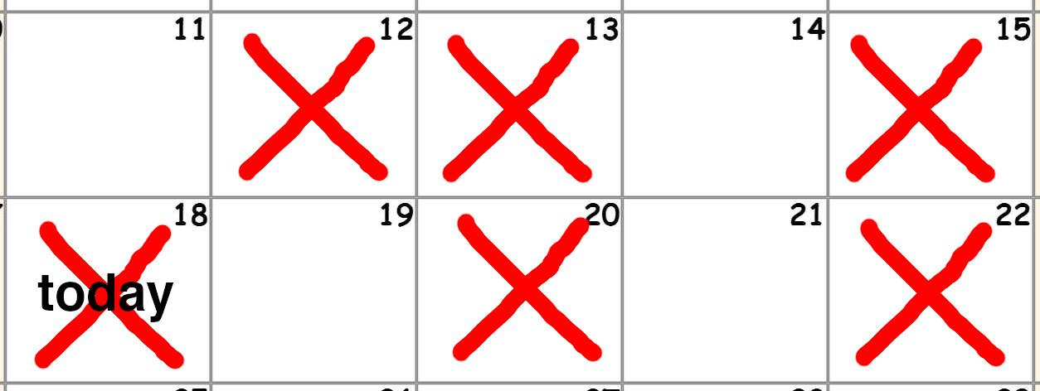

**(1) Scheduling Algorithm : Greedy**

Another year, another winter break. In practicing the above algorithm I frequently ended up in situations where I had empty days in the past and marked days in the future. Specifically in the given example, there are two slots empty in the past, and only two slots open in the future. I noticed that theoretically the optimal fitting is moving the future dates to fill the past dates.

For this example, if we were to have moved the marked 20 and 22 to fill the empty 11 and 14 then there would be zero slots open in the past and *four* slots open for the future.

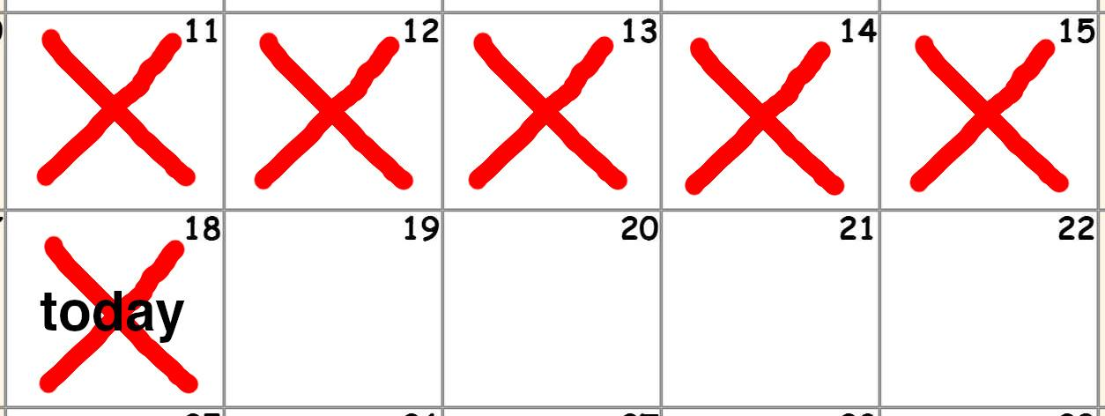

The premise of this realization is that time moves forward one day at a time! While looking at things after-the-fact all the empty days are of equal value, the linearity of time means that it is optimal to prioritize the days which will expire first!

Of course this is obvious in hindsight and at the time I was not thinking about this clearly with ‘algorithm’ language. Otherwise the solution would’ve been noticed much quicker but regardless coming to this realization organically was enjoyable and fun.

1. **Bandwidth : Money**

In college, I optimized for money. I wasn’t poor by any means but in terms of decision making I cared about value and monetary cost was weighted heavier.

1. **Bandwidth : Time**

While working, I began to optimize for time. I’m not wealthy by any means but money is no longer a bottleneck. I’ve lifestyle-creeped and am okay with spending more. The weights have shifted on the spectrum towards immediate experiences and away from long term investing optimization.

While working there is less free time than in college. However, I enjoy it because it is easier to plan. While the pie is smaller it is easier to allocate because there are pre-sliced sections. This makes decision making easier; I know when I am not free and I know when I am free. I can say yes or no to events without much calculation.

1. **Bandwidth : Energy**

After working for some time and optimizing my time slots - filling them with social events, I quickly found out how limited I am as a person. Of course real life isn’t so linear -- I already knew this from college experience but I was faced with limitations again after working.

It came to be that my bottleneck was no longer my time but my energy. I was going to events -- not that I wasn’t interested in -- but events that I would end up not enjoying or not being fully present (mentally) at. The reality diverged from the theoretical because . . . well I’m not a robot.

It certainly is nice to have things going on all the time. It feels good. And it feels even better to talk about. However, for myself, I came to hold that highly valuing your time does not necessitate having a full schedule. I don’t believe in filling a schedule and when people are extremely busy it might be a vice instead of a virtue.

Practically, one can start optimizing for energy by (1) sleep properly (lights, blinds, masks, weighted blanket, etc), (2) eat properly (conscious of intake, soylent, intermittent, diets, etc), (3) check health conditions (hypersomnia, apnea, liver, etc).

**(2) Scheduling Algorithm : Recurring Monthly**

I’m interested in people. This is my current algorithm where my friends are on a monthly recurring schedule. For instance, a person might be “the second Wednesday of the month”. The ‘month’ interval was chosen arbitrarily but it has turned out to be a good amount of time and a reasonable amount of change happens in a month.

The benefit of having a recurring monthly schedule is it removes the need for initiation; by default the event is occurring on this date. Of course, it is not a major issue if there is a conflict and our date needs to be rescheduled or skipped for next month. The system is simply to put it in the calendar and make it easy to check-in with the person as the day approaches to determine if we’re busy or still good to meet for the scheduled day.

The problem with this algorithm is that most things in life are on a weekly schedule. For example, I want to join a soccer league. The practice is Thursdays every week for the season. While I’m not busy every Thursday, with my monthly schedule there are people who fall on a Thursday. They can be moved if necessary, however it’s an unanticipated consequence.

Computers are useless. They can only give you answers.

<https://www.youtube.com/watch?v=P9dm_T5vynM>

Among Savages - New York City